I one（i818)

Product Specification

VER 1.0

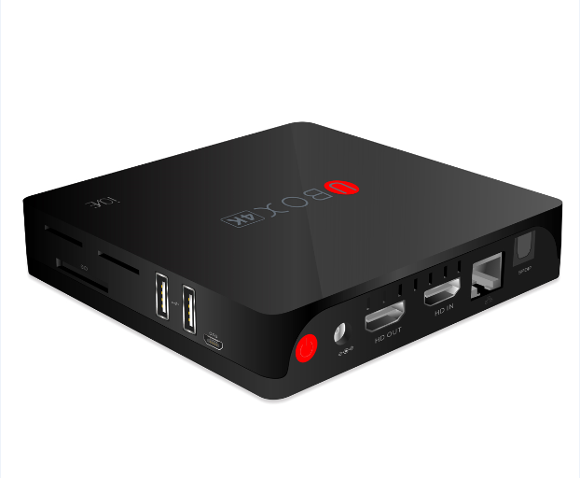

Revision History
Version | Issue Date | Comments | Author
1.0 | 2014-05-28 | First Version | Black Chan

Product Specification
Item |  | Description
Appearance | 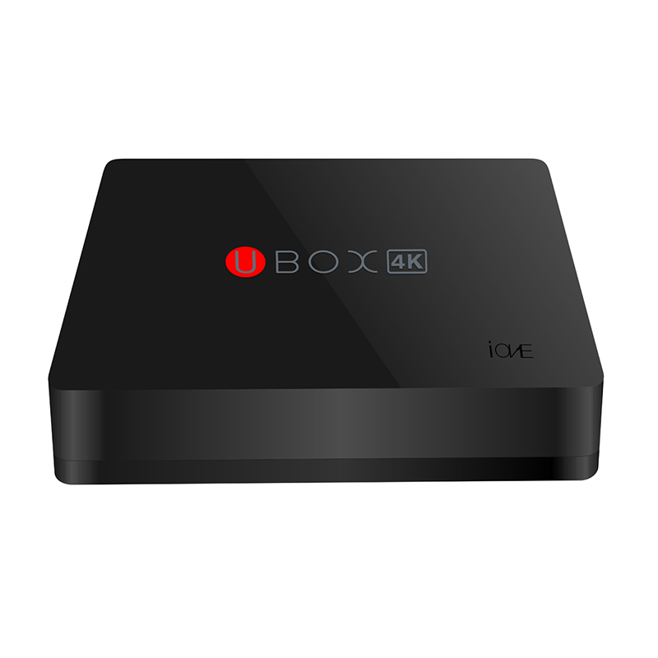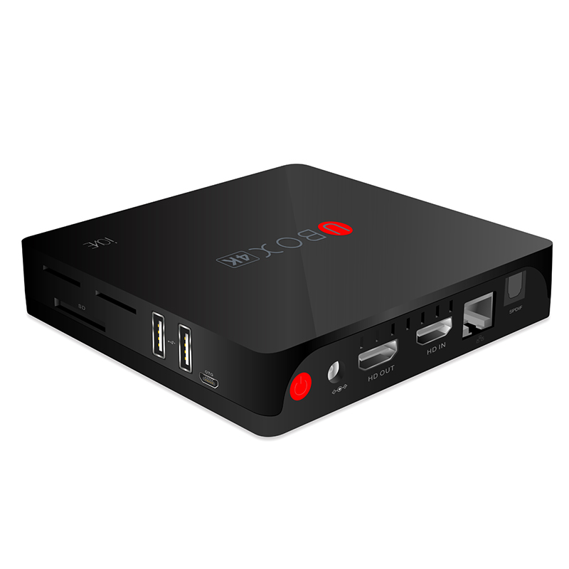
Appearance | Dimension | 119*119*23mm
System Config. | CPU | Amlogic S802 Quad Core up to 2.0GHz(Cortex-A9)
System Config. | GPU | Octa core ARM Mali-450 up to 600MHz
System Config. | RAM | DDR3 1GB
System Config. | ROM | Onboard eMMC Flash 8GB
System Config. | Bluetooth | BT 4.0
System Config. | Expand Memory | Micro SD Card (Maximum support 32GB)
System Config. | Antenna | Built-in antenna for WIFI
Media | Video/Picture Decoding | - H.265 HP@L5.0 up to 4Kx2K@30fps  - H.264 HP@L5.1 up to 4Kx2K@30fps  - H.264 MVC up to 1080P@60fps  - MPEG-4 ASP@L5 up to 1080P@60fps (ISO-14496)  - WMV/VC-1 SP/MP/AP up to 1080P@60fps  - AVS JiZhun Profile up to 1080P@60fps  - MPEG-2 MP/HL up to 1080P@60fps (ISO-13818)  - MPEG-1 MP/HL up to 1080P@60fps (ISO-11172)  - RealVideo 8/9/10 up to 1080P@60fps  - H.265 HEVC up to 720P  - WebM up to VGA  - Multiple language and multiple format sub-title video support  - MJPEG and JPEG unlimited pixel resolution decoding (ISO/IEC-10918)  - Supports JPEG thumbnail, scaling, rotation and transition effects  - Supports *.mkv,*.wmv,*.mpg, *.mpeg, *.dat, *.avi, *.mov, *.iso, *.mp4, *.rm and *.jpg file formats
Media | Audio format | Support: MP3, AAC, WMA, RM, FLAC, OGG
Communication | Ethernet | 10/100M LAN
Communication | WIFI | IEEE 802.11a/b/g/n/mimo
Communication | WIFI | IEEE 802.11a/b/g/n/mimo, WiFi compliant  2.400 GHz ~ 2.497 GHz (2.4 GHz ISM Band)  4.900 GHz ~ 5.845 GHz (5.0 GHz ISM Band)
Sensor/Motor | IR Sensor | 1*IR
Indicator | Power LED | 1* power LED with two - color
Button & Ports | Button | 1*Power Button
Button & Ports | Button | 1*Update Button(via one pin hole)
Button & Ports | USB2.0 | 2* Standard USB  1* micro USB with OTG
Button & Ports | DC-in | 1*DC in Jack
Button & Ports | H D IN | 1*H D IN Port
Button & Ports | H D OUT | 1*H D OUT Port
Button & Ports | SPDIF | 1*S/SPDIF (2CH, 5.1CH)
Button & Ports | RJ45 | 1*RJ45
Button & Ports | SD Card Slot | 1* SD card
Power management | Adapter | 5V 2A
Software Config. | OS | Google Android 4.4
Software Config. | Language | Multi -language
Software Config. | Keyboard | Qwerty keyboard
Features | Miracast/DLNA | Support
Features | UI | Support original ecology and AZW custom UI
Work Environment |  | 5°C--35°C，30%--90% Humidity
Storage Environment |  | -20°C--60°C，10%--90% Humidity

